**How to install k8s method Kubeadm install on ubuntu 20.04 LTS**

**Prerequisites**

**2 or 3 Ubuntu 20.04 LTS System with Minimal Installation**

**Minimum 2 or more CPU, 4 GB RAM. Master node**

**Minimum 1 or more CPU, 2 GB RAM, for Worker Node**

**Step1:**

**sudo su ( use this command for both Master and worker Node for root user)**

**use nano install.sh command for install docker and K8s bellow commands save**

**to run the command sh install.sh**

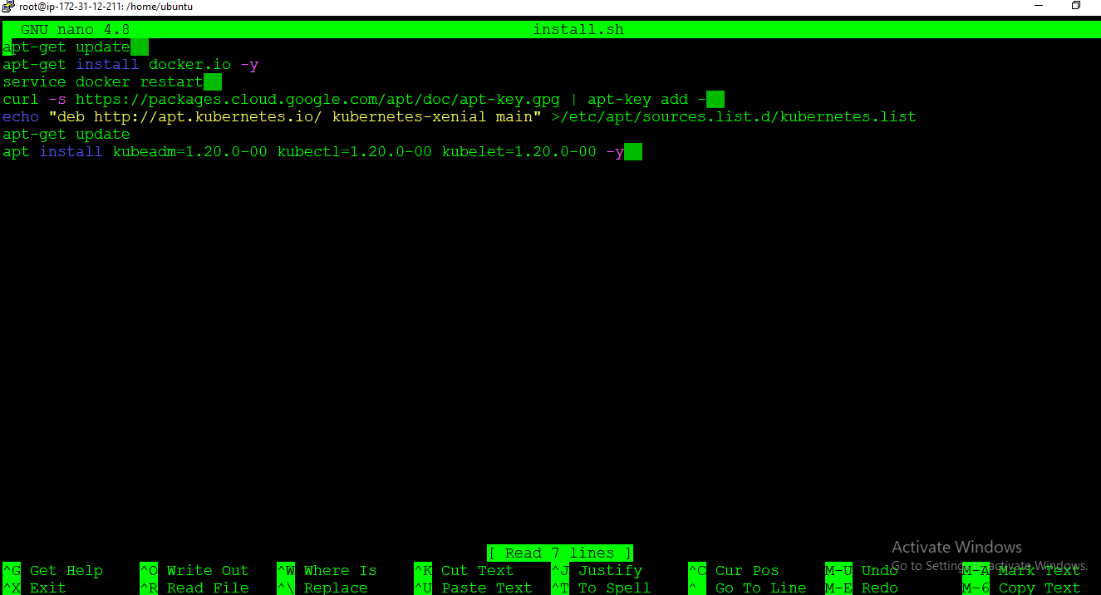

**To run bellow commands On Master & worker node by using Nano edit tab**

**apt-get update**

**apt-get install docker.io -y**

**service docker restart**

**curl -s https://packages.cloud.google.com/apt/doc/apt-key.gpg | apt-key add -**

**echo "deb http://apt.kubernetes.io/ kubernetes-xenial main" >/etc/apt/sources.list.d/kubernetes.list**

**apt-get update**

**apt install kubeadm=1.20.0-00 kubectl=1.20.0-00 kubelet=1.20.0-00 -y**

**Step2:**

**On Master:**

1. **kubeadm init --pod-network-cidr=192.168.0.0/16**

**>Copy the token and paste it into the worker node.**

**Step3:**

**On Master:**

**Exit and bellow 3 commands in master node**

1. **mkdir -p $HOME/.kube**
2. **sudo cp -i /etc/kubernetes/admin.conf $HOME/.kube/config**
3. **sudo chown $(id -u):$(id -g) $HOME/.kube/config**

**step4:**

**On Master:**

**curl https://raw.githubusercontent.com/projectcalico/calico/v3.25.0/manifests/calico.yaml -O**

**kubectl apply -f calico.yaml**

**kubectl apply -f https://raw.githubusercontent.com/kubernetes/ingress-nginx/controller-v0.49.0/deploy/static/provider/baremetal/deploy.yaml**

**Our Kubernetes installation and configuration are complete**

**For the status check use bellow command**

**kubectl get nodes**

